SIMATS ENGINEERING
ASSESSMENT TOOL 1 - SCENARIO BASED ASSIGNMENT
Course Name | Artificial Intelligence | Course Code | CSA17
Course Outcome | CO2 (BL3): Search and game-solving techniques - Greedy, A*, CSP, Minimax, Alpha-Beta with heuristics | Duration / Marks | 1 Hour / 50 (5 questions x 10)
Name / Reg No | YUKESH KUMAR(192524464) | Weightage | 35%

Code of Conduct: I Yukesh kumar J ( 19252446)(Name / Reg No) certify that this submission is my original work and that I have adhered to the guelines specified for this assessment. I understand that any violation of academic integrity rules will result in disciplinary action.
Signature of the student: ____________________

Question 1 - Drone Delivery in a Flood Zone (Greedy vs A*)
Scenario: Drones deliver emergency medicine in a flood region. Roads get blocked suddenly, weather changes travel cost, the heuristic is straight-line distance, and decisions must be fast with minimum delay and risk.

(i) Greedy Best-First Search (GBFS) in this scenario
GBFS expands the node with the lowest heuristic only: f(n) = h(n), where h(n) is the straight-line distance to the relief camp. The drone therefore always flies towards the neighbouring waypoint that looks closest to the goal and ignores the cost already spent (wind, storm, flooded terrain).
Strengths (under uncertainty) | Weaknesses (under uncertainty)
Very fast: the first route is found after few expansions.  Low memory and cheap to re-run after every new update.  Natural 'head for the goal' behaviour suits urgency. | Not optimal: ignores g(n), so it may pick a short but stormy / risky leg (see Figure 1).  Misled by straight-line distance: a river or blocked bridge can create dead ends.  Incomplete on graphs with loops unless a closed list is kept.  Worst case O(b^m) time and space.

(ii) How A* handles the same situation
A* uses f(n) = g(n) + h(n). Here g(n) is the actual cost already incurred, built from distance weighted by terrain and weather (time or risk), and h(n) is the straight-line estimate of the remaining cost. g keeps the search honest about real conditions, while h pulls it towards the goal. If h is admissible (never overestimates) the first path A* returns is optimal, and with a consistent h no node is re-expanded.
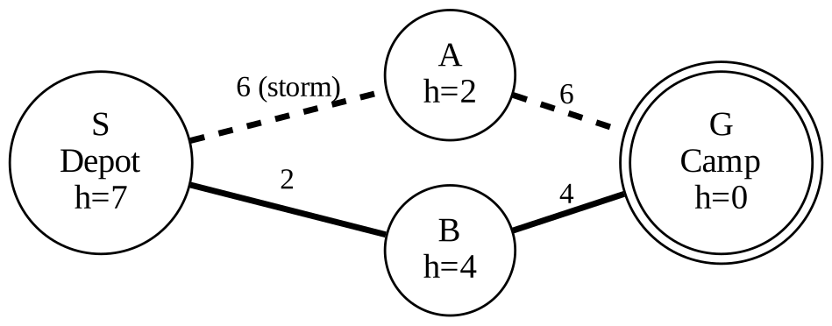
Figure 1: Same map, two behaviours. GBFS (dashed) goes S-A-G with cost 12; A* (solid) goes S-B-G with cost 6.
Step | GBFS (uses h only) | A* (uses g + h)
From S | h(A)=2 < h(B)=4, so choose A | f(A)=6+2=8, f(B)=2+4=6, so choose B
Next | A to G (6) | B to G (4)
Result | Cost = 12 (stormy leg used) | Cost = 6 (optimal)

(iii) Impact of heuristic accuracy
Heuristic quality | Effect on GBFS | Effect on A*
Accurate (close to true cost) | Goes almost straight to goal; very fast. | Expands very few nodes; stays optimal.
Weak (h near 0) | Behaves almost blindly; slow and erratic. | Degrades to Uniform-Cost / Dijkstra; still optimal but slow.
Over-estimating (inadmissible) | No guarantee anyway; may cut through danger. | Loses optimality and may skip the safest route.
Straight-line in a flood | Optimistic: floods force detours, so it is misled into dead ends. | Safe because it never over-estimates, but expands more nodes.
Key point: GBFS depends entirely on h, so its quality collapses when h is poor; A* only loses speed, not correctness, as long as h is admissible.

(iv) Effect of dynamic changes (blocked paths)
A blocked road makes the current plan invalid, so the drone must sense, update and replan (Figure 2). GBFS replans cheaply but can repeatedly walk into the same blocked pocket because it never remembers cost. A* replans more expensively, but the updated g-values route around the block optimally. Incremental versions (D* Lite, LPA*) reuse earlier search effort so only the affected part is recomputed. Uncertain edges can be given a risk penalty in g(n). Performance is judged by nodes expanded, number of replans and added delay.
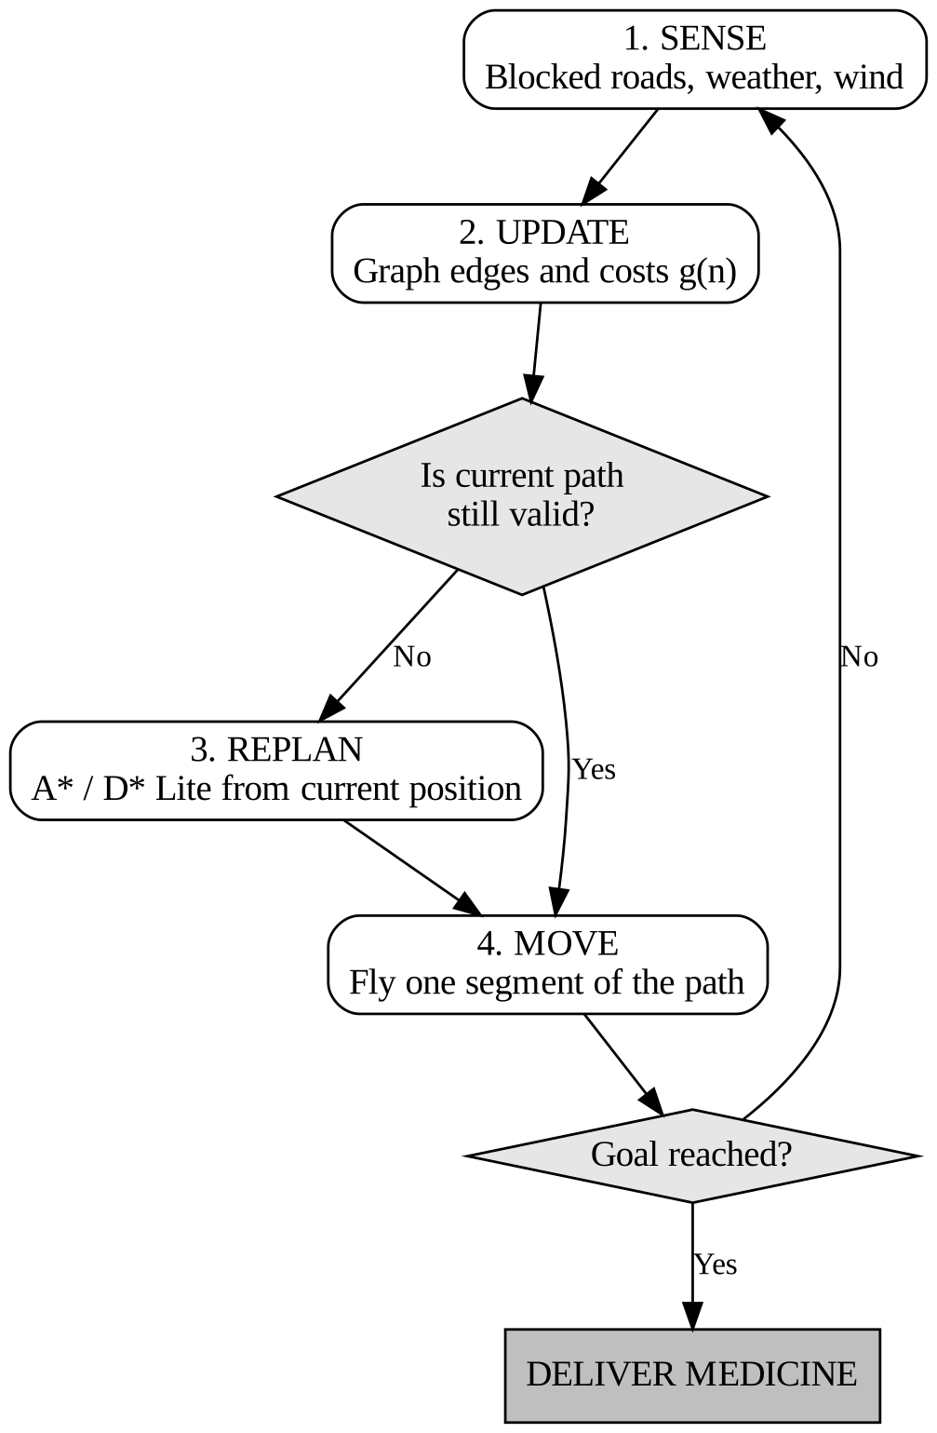
Figure 2: Sense-update-replan loop for a dynamic environment.

(v) Recommendation
Recommended: A* (in its dynamic form, D* Lite, or Weighted A* with f = g + w*h, w around 1.2).
Criterion | GBFS | A* / D* Lite
Real-time speed | Fastest | Fast enough on a waypoint graph; weighted version bounds time
Optimality | No | Yes (admissible h); weighted gives cost within w x optimal
Safety | Ignores weather / risk cost | Risk and weather built into g(n)
Handles blocked paths | Poorly | Well, with incremental replanning
Justification: a drone cannot afford an unsafe or very long route when medicine is urgent. A* gives a provably good route, and the weighted or incremental variants keep the delay within real-time limits.

Question 2 - Smart-City Traffic Signal Optimization
Scenario: An AI system optimizes signal timings over hundreds of intersections to minimize waiting time, fuel use and congestion. The search space is huge, traffic is dynamic and the system may get stuck in local optima.

Problem formulation
Element | Definition
State | Vector x = (cycle length, green split, offset) for each of the n intersections.
Neighbour move | Change one parameter at one intersection by a small step (for example, +/- 2 s of green).
Objective | Minimize Cost(x) = a*TotalWaitTime + b*FuelConsumption + c*Congestion (weights a, b, c set by city policy). Equivalent to maximizing 1/Cost.
Constraints | Minimum green and pedestrian crossing time, maximum cycle length, emergency-vehicle priority.
Evaluation | Traffic simulator or live sensor data computes Cost(x).
Why traditional search is inefficient: (1) The space is exponential: if each of 500 intersections has 10 timing choices there are 10^500 states, so BFS, DFS and A* run out of time and memory. (2) There is no single goal state and the path to the solution is irrelevant; only the quality of the final configuration matters. (3) Every state evaluation needs a simulation, which is costly. (4) Traffic changes constantly, so a stored plan quickly becomes stale. Local search keeps only the current state (O(1) memory) and improves it continually, which suits this problem.

(i) Hill Climbing and its limitations
Start with the current timing plan, generate neighbouring plans, move to the best neighbour if its cost is lower, and stop when no neighbour improves (steepest-ascent). Variants are stochastic, first-choice and random-restart hill climbing.
- Strengths: tiny memory, fast, can run online and keep adjusting as traffic changes.
- Limitations: gets stuck at local optima, plateaus and ridges; never accepts a worse move, so it cannot backtrack; the result depends strongly on the starting plan; no guarantee of the global optimum.

(ii) Local maxima, plateaus and ridges (real-world meaning)
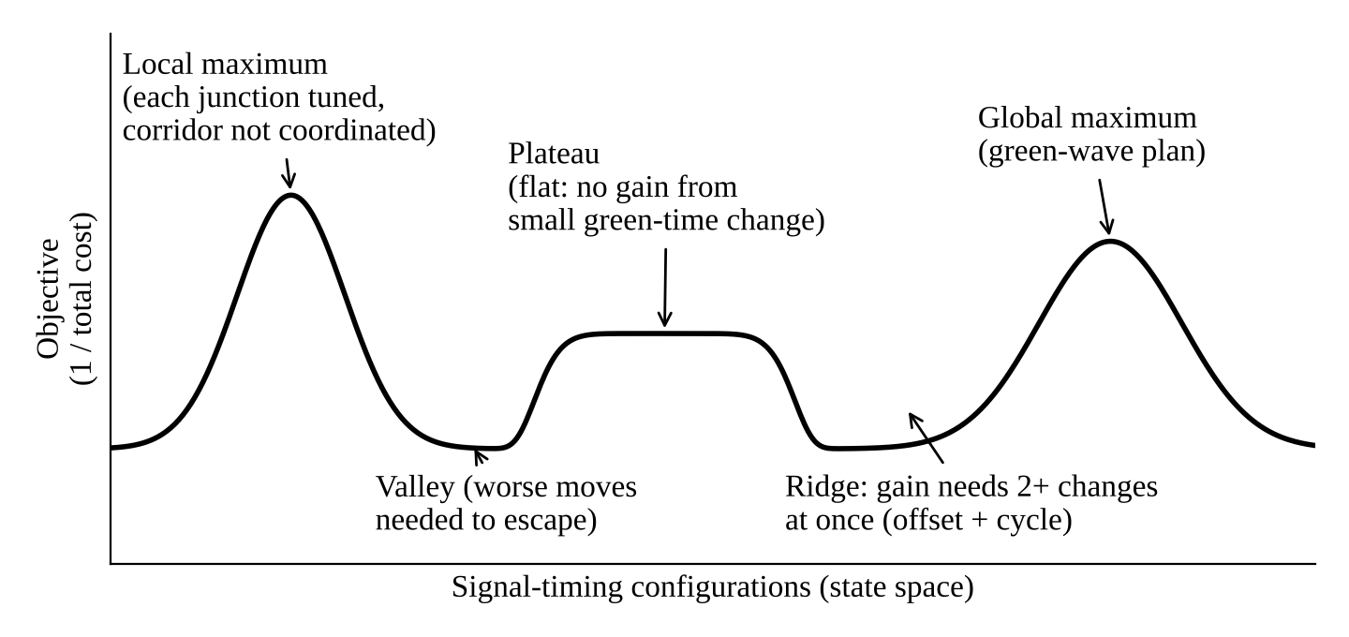
Figure 3: State-space landscape for the signal-timing objective.
Problem | Meaning | Traffic example
Local maximum | Better than all neighbours but worse than the best solution. | Every junction is tuned alone, yet the corridor has no coordinated 'green wave'; any single change makes things worse.
Plateau | Flat region; all neighbours have equal cost. | Off-peak, traffic is below capacity so a few seconds of green changes nothing; the algorithm has no direction.
Ridge | A narrow path of improvement; single moves go downhill, but two or more together go uphill. | Offset and cycle length of neighbouring junctions must change together to synchronize; changing one alone increases waiting.

(iii) How Simulated Annealing and Genetic Algorithms overcome these limits
Simulated Annealing (SA): pick a random neighbour. If it is better, accept it. If it is worse, accept it with probability e^(-dE/T), where dE is the increase in cost and T is the temperature. T is lowered gradually (cooling). Early on, T is high so the system explores and escapes local optima and plateaus; later, T is low so it settles like hill climbing. With slow cooling it converges to the global optimum.
Genetic Algorithm (GA): keep a population of complete timing plans (chromosomes). Evaluate fitness by simulation, select the fittest, apply crossover (swap corridor or zone plans between parents) and mutation (small random changes), and repeat (Figure 4). Many points are searched in parallel, and crossover combines good sub-plans, which solves the ridge problem that single-step moves cannot.
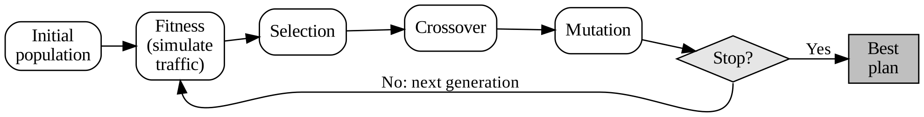
Figure 4: Genetic Algorithm cycle for signal-plan optimization.
Feature | Hill Climbing | Simulated Annealing | Genetic Algorithm
Escapes local optima | No | Yes (random uphill moves) | Yes (population, crossover, mutation)
Memory | One state | One state | Population of states
Cost per step | Lowest | Low | High (many simulations)
Parallelism | Poor | Poor | Excellent
Adapts to change | Good, fast | Good (re-heat T) | Good (warm-start population)

(iv) Recommendation
Recommended: a hybrid (memetic) approach, Genetic Algorithm for global plan search with hill-climbing / SA fine-tuning online.
- Scalability: split the city into zones or corridors, evolve zone plans in parallel on many processors and combine them; the cost grows roughly linearly with zones rather than exponentially with intersections.
- Adaptability: keep the last best population as the starting point when traffic changes, then apply a cheap SA or hill-climbing step in real time (re-heating T slightly) for small fluctuations.
- Reliability: population diversity avoids local optima; the local refinement removes the GA's slow, noisy final convergence.

Question 3 - Autonomous Mars Rover (Online Search)
Scenario: A rover explores unknown terrain, must collect samples safely, avoid craters and rocks, has limited sensing and no complete map, and updates its knowledge as it explores.

(i) Why an online search agent is needed
An offline agent computes the complete plan first and then executes it; this needs a full, correct model of the world. An online agent interleaves planning and acting: it plans a little, acts, observes and plans again. The rover needs the online approach because:
- The map is unknown, so a full plan cannot be computed in advance (exploration problem).
- Sensors see only a short range around the rover.
- Earth-Mars signal delay (minutes) makes remote step-by-step control impossible; decisions must be made on board.
- Actions can be irreversible (falling into a crater), so the agent must verify the next step with fresh sensor data before taking it.

(ii) Challenges of partial observability and dynamic environments
Challenge | Explanation / Rover example
Limited percepts | Only nearby cells are visible; hazards beyond the sensor range are unknown.
Sensor noise and aliasing | Shadows, dust and similar-looking rocks make different states look the same; the rover must maintain a belief about its true state.
Localization drift | Wheel slip in sand causes position error that accumulates.
Dynamic changes | Dust storms, rolling rocks, changing light and battery / thermal limits make old plans stale.
Dead ends and irreversibility | Entering a pocket or unsafe slope may leave no way back, so exploration must be cautious.
Real-time limits | Limited on-board computation and energy restrict how deeply it can plan.

(iii) Building and updating the internal model
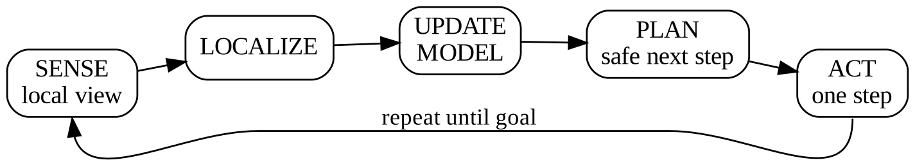
Figure 5: Online agent cycle (sense - localize - update model - plan - act).
- Map: an occupancy grid where each cell is Unknown, Free, Obstacle or Hazard (with a probability). Sensor data updates cells as they come into view.
- Transition record: the agent stores result[s, a] = s' for every action it has actually tried, so it learns how the world responds.
- Visited / unexplored lists: record which states still have untried actions so the rover can backtrack physically.
- Cost estimates: as in LRTA*, update H(s) = min over actions of [ c(s,a) + H(result(s,a)) ], so repeatedly visited poor states become less attractive and the agent does not loop.
- Safety layer: inflate the cost around hazards and keep battery reserve so the model supports safe choices.

(iv) Online search compared with uninformed and informed search
Aspect | Uninformed (BFS, DFS, UCS) | Informed (A*, GBFS) | Online (LRTA*, online DFS, D* Lite)
Needs full map | Yes | Yes | No; learns while moving
When it plans | Before acting | Before acting | Repeatedly while acting
Uses heuristic | No | Yes | Yes, updated through experience
Handles unknown / changing terrain | No | No (must restart) | Yes
Safety in real world | Plans on paper only | Plans on paper only | Can verify each step
Optimality | BFS / UCS optimal | A* optimal | Not guaranteed; measured by competitive ratio

(v) Most suitable approach
Recommended: online informed search, for example LRTA* / D* Lite with a hazard-weighted heuristic and a receding planning horizon.
- Uncertainty: replans after every new observation using the latest map; belief-based localization handles noisy sensing.
- Adaptability: D* Lite repairs the existing plan when new obstacles appear instead of restarting.
- Safety: hazard cells carry very high cost, only reversible or verified steps are taken, and the rover keeps a safe retreat path and energy reserve.
- Efficiency: the heuristic (distance to the sample site) focuses exploration, avoiding the blind wandering of uninformed online DFS.

Question 4 - University Exam Timetabling (CSP)
Scenario: An AI system must generate exam timetables with no student clash, limited halls, precedence between subjects, faculty availability and special accommodations; the problem grows with courses and students.

(i) CSP formulation: variables, domains, constraints
Component | Definition | Explanation
Variables | T_c (time slot) and H_c (hall) for every course c | One decision for when and where each exam is held.
Domains | T_c in {1..D x S} (D days x S sessions, e.g. 10 x 3 = 30 slots); H_c in {halls with capacity >= enrolment of c} | Finite discrete domains; unary constraints already shrink them.
C1: No student overlap | T_a != T_b for every pair of courses a, b sharing a student | Binary constraint; forms the conflict graph (like graph colouring).
C2: Limited halls | If T_a = T_b then H_a != H_b; total enrolment in a hall at one slot <= capacity | Global constraint (AllDiff on (slot, hall) pairs).
C3: Precedence | T_a < T_b if subject a must be before b | Binary ordering constraint.
C4: Faculty | T_c in Available(faculty of c); one faculty member cannot invigilate two exams in the same slot | Unary plus binary constraints.
C5: Special accommodation | Extra-time or separate-room students: H_c restricted to suitable rooms; longer slot reserved | Unary domain restriction.
Soft constraints (optional) | Avoid consecutive-day exams for a student; spread the load | Handled by minimizing a penalty after hard constraints are satisfied.
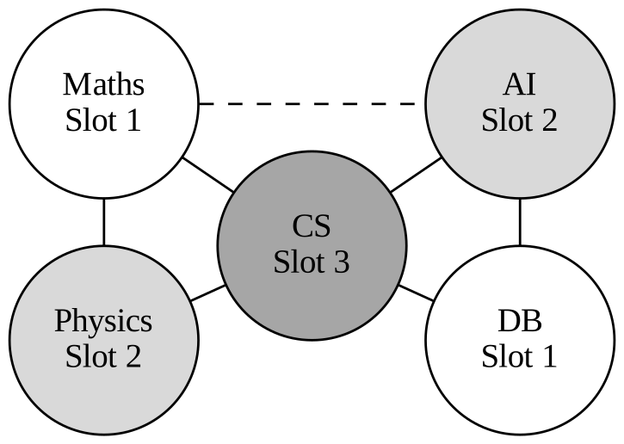
Figure 6: Constraint graph (edges = shared students, so slots must differ; dashed = precedence). A valid 3-slot solution is shown.

(ii) Backtracking search
Backtracking is depth-first search that assigns one variable at a time and checks consistency with the constraints already satisfied. If a violation occurs, it undoes the last assignment (backtracks) and tries the next value. Ordering heuristics make it practical: MRV (choose the variable with fewest legal values, e.g. an exam with limited faculty availability), Degree (most constraints, e.g. a core subject shared by many students) and LCV (try the value that rules out the fewest options for neighbours).
Step | Assignment | Check | Action
1 | Maths = Slot 1 | No conflict | Continue
2 | Physics = Slot 1 | Shares students with Maths | Backtrack, try Slot 2
3 | Physics = Slot 2 | OK | Continue
4 | CS = Slot 1, then 2 | Conflicts with Maths, then Physics | Try Slot 3: OK
5 | AI = Slot 1 | Violates 'Maths before AI' | Try Slot 2: OK; then DB = Slot 1: OK, solution found

(iii) Constraint propagation and forward checking
Forward checking: whenever a variable is assigned, remove the inconsistent values from the domains of its unassigned neighbours. If any domain becomes empty, backtrack immediately instead of discovering the failure many levels deeper.
Example: after Maths = Slot 1, delete Slot 1 from the domains of Physics, CS and AI (they share students or have precedence), so those exams are never tried in Slot 1. If Physics and CS were both left with only Slot 2, the stronger arc consistency (AC-3 / MAC) would detect the clash at once because they conflict with each other.
- Benefits: early failure detection, far fewer nodes explored, avoids repeated thrashing on the same cause of failure.
- Cost: extra work per assignment, but it is almost always repaid by the pruning.

(iv) Real-world challenges and best strategy for scalability
Challenge | Why it matters
Thousands of courses, dense conflict graph | Plain backtracking becomes exponential.
Over-constrained instances | No perfect timetable exists; some constraints must be relaxed.
Late changes (new registrations, hall breakdown) | Re-solving from scratch is slow and changes too much.
Soft preferences and fairness | Hard CSP alone does not rank the solutions.

Best strategy (layered):
- Preprocess with unary constraints and arc consistency to shrink domains.
- Solve with backtracking using MRV + Degree + LCV + forward checking / MAC (graph-colouring heuristics such as DSATUR work well) and conflict-directed backjumping.
- Decompose the problem by department, exam week or independent subgraphs and solve parts in parallel.
- For updates and very large inputs use min-conflicts local search to repair an existing timetable by changing only the violated exams; optimize soft constraints afterwards.
This combination keeps the guarantees of systematic search on the hard constraints while remaining scalable and quick to repair.

Question 5 - Real-Time Strategy Game AI (Minimax and Alpha-Beta)
Scenario: An AI opponent must compete against humans, decide within strict time limits, evaluate complex game states with many moves, and the decision tree is extremely large.

(i) How Minimax models the problem
The game is treated as a two-player, zero-sum adversarial search problem. MAX is the AI and MIN is the human opponent. The model has: initial state, PLAYER(s), ACTIONS(s), RESULT(s,a), TERMINAL-TEST(s) and UTILITY(s) (win, draw, loss, or a score). Minimax assumes the opponent plays optimally:
MINIMAX(s) = UTILITY(s) if s is terminal; max over actions of MINIMAX(RESULT(s,a)) if MAX moves; min over actions of MINIMAX(RESULT(s,a)) if MIN moves.
It is a depth-first traversal: values flow up from the leaves, MAX picks the largest child value and MIN the smallest. In an RTS the continuous game is discretized into decision ticks and abstracted (groups of units, key actions) so that it fits this turn-based model.

(ii) Computational challenges of large game trees
- Time O(b^m), space O(b*m) for branching factor b and depth m. Chess alone has b about 35 and m about 80, so about 35^80 (roughly 10^123) nodes; an RTS with many units has an even larger b.
- Strict time limit: only milliseconds per frame are available, so full-depth search is impossible; a depth limit and an evaluation function are required.
- Beyond the model: hidden information (fog of war), real-time simultaneous moves and randomness break the perfect-information assumption.
- Cost per node: generating states and evaluating a complex game position is expensive.

(iii) How Alpha-Beta pruning improves efficiency
Alpha-Beta keeps two bounds while searching: alpha = best value MAX can already guarantee on the current path, beta = best value MIN can already guarantee. A branch is cut when alpha >= beta, because the opponent would never allow the game to reach it. The result is identical to Minimax; only useless work is removed.
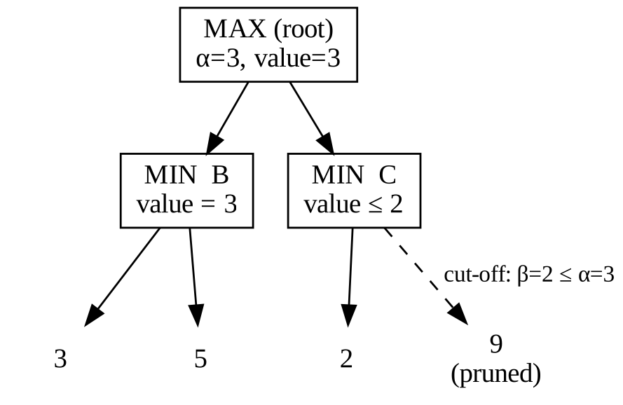
Figure 7: Alpha-Beta pruning. The leaf 9 is never examined.
- Search B: MIN sees leaves 3 and 5, so B = min(3, 5) = 3. The root (MAX) now has alpha = 3.
- Search C: the first leaf is 2, so MIN can force C <= 2 (beta = 2).
- Since beta = 2 <= alpha = 3, MAX already has a better option (B = 3), so C's remaining leaf (9) is pruned. Root value = 3.
Case | Nodes examined | Meaning
Worst order | O(b^m) | No pruning; same as Minimax.
Random order | About O(b^(3m/4)) | Moderate saving.
Best (perfect) ordering | O(b^(m/2)) | Can search twice as deep in the same time.
Move ordering (try captures, strong attacks and the previous best move first), killer moves and transposition tables push the search towards the best case.

(iv) Evaluation function design
The tree cannot be searched to the end, so the search stops at a depth limit and estimates the position with a weighted linear function: Eval(s) = w1*f1 + w2*f2 + ... + wn*fn, with all features normalized (own minus enemy).
Feature | Weight | Why it is included
f1: Army strength (unit count x unit value, health) | 0.30 | Direct measure of fighting power and the main predictor of winning battles.
f2: Economy (resources, income, workers) | 0.20 | Long-term ability to produce units.
f3: Map control / territory and vision | 0.20 | Control of key points restricts the opponent and gives information.
f4: Base safety (building health, defence) | 0.15 | Losing the base ends the game; a large penalty near terminal loss.
f5: Technology / upgrades | 0.10 | Future advantage.
f6: Mobility / tempo (available options, army position) | 0.05 | Flexibility to attack or defend.
The function must be fast (called at millions of leaves), correlated with winning, and consistent with terminal utilities (win = very large positive, loss = very large negative). Weights can be tuned from replays, by regression, or by self-play / reinforcement learning.

(v) Strategy for balancing optimality and real-time performance
- Iterative-deepening Alpha-Beta with a time budget: search depth 1, 2, 3 ... until time expires and play the best move from the last completed depth (an anytime algorithm that always has an answer).
- Move ordering and transposition tables to approach the best-case O(b^(m/2)) pruning and avoid repeated states.
- Depth-limited search with the evaluation function and quiescence search (search deeper only where the position is unstable, such as fights in progress).
- Forward pruning / beam search to look only at the most promising few moves, and abstraction of units into squads to reduce b.
- For extremely large branching or hidden information, Monte-Carlo Tree Search can be used alongside, but the core recommendation is time-bounded Alpha-Beta because it is predictable and meets the frame deadline.
Technique | Gain | Trade-off
Alpha-Beta + ordering | Same quality, far fewer nodes | Needs good move ordering
Depth limit + Eval | Fits time limit | Quality depends on Eval accuracy
Iterative deepening | Always a move ready | Small repeated work
Forward pruning | Much smaller b | May miss a surprising good move

RUBRICS FOR CALCULATION
Assessment rubric (applied to each question, 10 marks per question, 50 in total) and where this answer script meets each criterion.
Criteria | Weight | Level 4 (Exemplary) | Level 3 (Proficient) | Level 2 (Developing) | Level 1 (Beginning) | Addressed in this answer
Understanding of Scenario | 20% | Clear, complete understanding of scenario and context | Good understanding, minor gaps | Partial understanding; misses key aspects | Misinterprets or fails to understand | Each question restates the scenario and builds a formal model (states, variables, objective).
Identification of Key Issues | 20% | Accurately identifies all relevant issues and factors | Identifies most issues, minor omissions | Limited issues; some irrelevant points | Unable to identify key issues | Uncertainty, dynamic change, local optima, partial observability, scale and time limits are analysed.
Application of Concepts | 25% | Applies appropriate concepts effectively to the scenario | Applies concepts with minor errors | Limited or partially correct application | Unable to apply relevant concepts | GBFS, A*, hill climbing, SA, GA, online search, CSP, Minimax and Alpha-Beta applied with worked examples.
Decision Making | 20% | Well-reasoned, logical decisions with strong rationale | Reasonable decisions with some justification | Weak decisions, limited justification | No clear decisions or rationale | Every question ends with a justified recommendation and a comparison table.
Clarity of Response | 15% | Clear, structured, logically presented | Generally clear, minor issues | Somewhat unclear or poorly structured | Disorganized, difficult to understand | Part-wise headings (i)-(v), diagrams, tables and consistent formatting.

Marks calculation per question (out of 10): Marks = (20% x Understanding + 20% x Key Issues + 25% x Application + 20% x Decision Making + 15% x Clarity), where each criterion is scored on the 4-level scale and converted to its share of the 10 marks.
Criterion | Weight | Marks out of 10 (Level 4) | Level 3 (75%) | Level 2 (50%) | Level 1 (25%)
Understanding of Scenario | 20% | 2.0 | 1.5 | 1.0 | 0.5
Identification of Key Issues | 20% | 2.0 | 1.5 | 1.0 | 0.5
Application of Concepts | 25% | 2.5 | 1.9 | 1.25 | 0.6
Decision Making | 20% | 2.0 | 1.5 | 1.0 | 0.5
Clarity of Response | 15% | 1.5 | 1.1 | 0.75 | 0.4
Total | 100% | 10.0 | 7.5 | 5.0 | 2.5

